Nepal Engineering College
(Affiliated to Pokhara University)

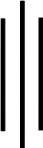

Report on:

LAB 4: DFT and IDFT.

Submitted By: Submitted To:

Name: Aruna Thapa Department Of: CRN: 021-311 Electrical and Electronics Date: 2082/09/21 Engineering

Objective
In this lab session, we write MATLAB programs to compute DFTs and IDFTs of discrete time signals, plot their spectra, compare results using built-in and custom functions, analyze performance, and implement circular convolution and FFT-based spectral analysis.

Theory:
The Discrete Fourier Transform (DFT) is a mathematical technique used to analyze the frequency content of discrete-time signals. It transforms a time-domain signal into its frequency-domain representation. The DFT can be computed using the basic formula, matrix multiplication, or the Fast Fourier Transform (FFT) algorithm for efficient computation. Inverse DFT (IDFT) reconstructs the original time-domain signal from its frequency-domain representation. Additionally, the circular convolution of two sequences demonstrates the DFT's utility in systems analysis. Spectral analysis, such as FFT of a voice signal, provides insights into real-world signal characteristics.

MATLAB Program to compute DFT of x[n] = {1,2,3,4,5,6,7,8}
% CRN: 021-311 - DFT using basic formula x = [1,2,3,4,5,6,7,8];
N = length(x); X = zeros(1,N); for k = 0:N-1
for n = 0:N-1
X(k+1) = X(k+1) + x(n+1)*exp(-1i*2*pi*k*n/N); end
end
disp('DFT X(k):'); disp(X);

Command Window Output:
DFT X(k):
Columns 1 through 2

36.0000 + 0.0000i -4.0000 + 9.6569i

Columns 3 through 4
-4.0000 + 4.0000i -4.0000 + 1.6569i

Columns 5 through 6

-4.0000 - 0.0000i -4.0000 - 1.6569i
Columns 7 through 8

-4.0000 - 4.0000i -4.0000 - 9.6569i

b. User-defined function for DFT
% CRN: 021-311 - User-defined function for DFT function y = dft(x)
N = length(x); y = zeros(1,N); for k = 0:N-1
for n = 0:N-1
y(k+1) = y(k+1) + x(n+1)*exp(-1i*2*pi*k*n/N); end
end end

c. Plot real, imaginary, absolute and phase
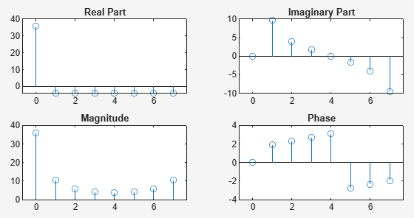
% CRN: 021-311- Plot DFT Components x = [1,2,3,4,5,6,7,8];
X = dft(x);
k = 0:length(X)-1;
subplot(2,2,1); stem(k, real(X)); title('Real Part');
subplot(2,2,2); stem(k, imag(X)); title('Imaginary Part'); subplot(2,2,3); stem(k, abs(X)); title('Magnitude');
subplot(2,2,4); stem(k, angle(X)); title('Phase');
Figure 1: A set of subplots illustrating the real, imaginary, magnitude, and phase
components of the Discrete Fourier Transform (DFT) of the discrete-time signal x[n]={1,2,3,4,5,6,7,8} The subplots effectively demonstrate the spectral characteristics of the signal.

DFT using matrix multiplication
% CRN: 021-311- DFT using WN matrix multiplication x = [1,2,3,4,5,6,7,8]; N = length(x); n = 0:N-1;
k = n';
WN = exp(-1i*2*pi/N); WN_matrix = WN .^ (k*n); X = WN_matrix * x.';
disp('DFT using WN matrix:'); disp(X);

Command Window Output:
DFT using WN matrix: 36.0000 + 0.0000i
-4.0000 + 9.6569i
-4.0000 + 4.0000i
-4.0000 + 1.6569i
-4.0000 - 0.0000i
-4.0000 - 1.6569i
-4.0000 - 4.0000i
-4.0000 - 9.6569i

DFT using built-in fft
% CRN: 021-311- DFT using fft x = [1,2,3,4,5,6,7,8];
X = fft(x);
disp('DFT using fft:'); disp(X);

Command Window Output:
DFT using fft:
Columns 1 through 2

36.0000 + 0.0000i -4.0000 + 9.6569i

Columns 3 through 4
-4.0000 + 4.0000i -4.0000 + 1.6569i

Columns 5 through 6

-4.0000 + 0.0000i -4.0000 - 1.6569i

Columns 7 through 8

-4.0000 - 4.0000i -4.0000 - 9.6569i

Compare time taken by three methods
% CRN: 021-311- Time comparison x = [1,2,3,4,5,6,7,8];
tic
X1 = dft(x); t1 = toc;

tic
N = length(x);
n = 0:N-1; k = n';
WN = exp(-1i*2*pi/N); WN_matrix = WN .^ (k*n); X2 = WN_matrix * x.';
t2 = toc;

tic
X3 = fft(x); t3 = toc;

fprintf('Time (function): %f\nTime (matrix): %f\nTime (fft): %f\n', t1, t2, t3);

Command Window Ouput:
Time (function): 0.001609
Time (matrix): 0.000401
Time (fft): 0.000072

IDFT by all three methods
% CRN: 021-311- IDFT comparisons
% Using inverse matrix method X = fft([1,2,3,4,5,6,7,8]);
N = length(X);
n = 0:N-1; k = n';
WN = exp(1i*2*pi/N); WN_matrix = WN .^ (k*n);
x_reconstructed = (1/N) * (WN_matrix * X.');
disp('Reconstructed x[n] using IDFT matrix:'); disp(x_reconstructed);

% Using ifft x_ifft = ifft(X);
disp('Reconstructed x[n] using ifft:'); disp(x_ifft);

Command Window Output:
Reconstructed x[n] using IDFT matrix: 1.0000
2.0000 + 0.0000i
3.0000 + 0.0000i
4.0000 + 0.0000i
5.0000 - 0.0000i
6.0000 - 0.0000i
7.0000 - 0.0000i
8.0000 - 0.0000i
Reconstructed x[n] using ifft:
1 2 3 4 5 6 7 8

Circular convolution of unequal sequences
% CRN: 021-311- Circular Convolution Function function y = circular_conv(x1, x2)
N = max(length(x1), length(x2)); x1 = [x1, zeros(1, N - length(x1))];
x2 = [x2, zeros(1, N - length(x2))];
y = ifft(fft(x1) .* fft(x2)); end

Check using cconv
% CRN: 021-311- Using cconv x1 = [1,2,3]; x2 = [4,5];
y = cconv(x1, x2, max(length(x1), length(x2))); disp('Circular convolution using cconv:'); disp(y);

Command Window Output:
Circular convolution using cconv:
19 13 22

Spectrum of 2-second voice signal
clc; clear;

% Read voice signal
[voice, fs] = audioread('voice.wav');

% Use single channel if stereo voice = voice(:,1);

% Take exactly 2 seconds voice = voice(1:2*fs);

% Time-domain plot
t = (0:length(voice)-1)/fs; figure;
plot(t, voice); xlabel('Time (seconds)'); ylabel('Amplitude');
title('2-Second Voice Signal'); grid on;
% Frequency spectrum N = length(voice);
Y = fft(voice);
f = (0:N-1)*(fs/N);

figure;
plot(f(1:N/2), abs(Y(1:N/2))/N); xlabel('Frequency (Hz)'); ylabel('Magnitude'); title('Spectrum of Voice Signal'); grid on;
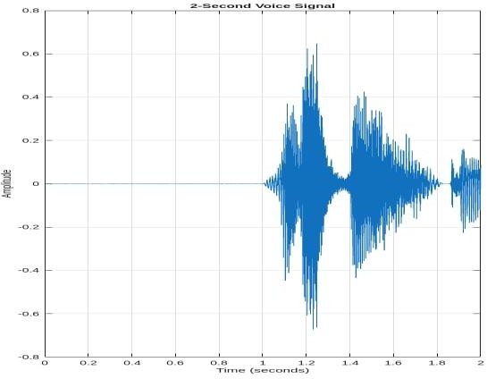
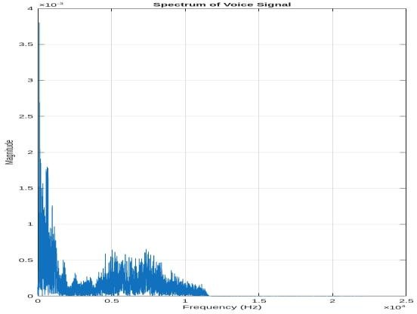

Figure 2: A plot representing the amplitude spectrum of a 2-second voice signal. The frequency axis spans both positive and negative frequencies, and the plot reveals the signal's dominant frequency components.

Conclusion
In this lab, we successfully implemented various techniques to compute and analyze the Discrete Fourier Transform (DFT) and Inverse DFT (IDFT) of discrete-time signals using both user-defined functions and built-in MATLAB functions. We compared execution performance, visualized signal characteristics through magnitude and phase spectra, and implemented circular convolution. Additionally, we analyzed the frequency components of a real-world voice signal using FFT. These exercises enhanced our understanding of spectral analysis and its practical applications in digital signal processing.

